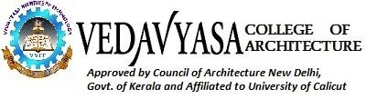

Ref: VCA/IIIC/**19-20** Date:

To

The Manager

HR Department

Sowparnika Enter

Address

Dear Sir/Madam

Sub: Industrial Visit for B.Arch Students

As a part of our academic curriculum, Industrial visit is mandatory for

B.Arch students. The following students and faculty members of Architectural Engineering of this institution are interested to visit your esteemed organization on ------. They may be given permission, subject to the rules of the organization.

I assure that the students will abide by all the rules and regulations stipulated by

your organization.

If large group then enclose in a separate sheet

List of Students and Faculty enclosed.

OR (use whichever is applicable)

Name of the student Branch of study

1. Ashok John B.Arch
2. Johns Rippon B.Arch

If large group then enclose in a separate sheet

Thanking you,

Yours faithfully,

Ar.Anish.C.S Ar.Shereef.T.P

Principal Head of the Department

**Coordinator**

Ar.Shereef.T.P

Head of the Department,

**Chair person**

Ar.Anish.C.S PRINCIPAL